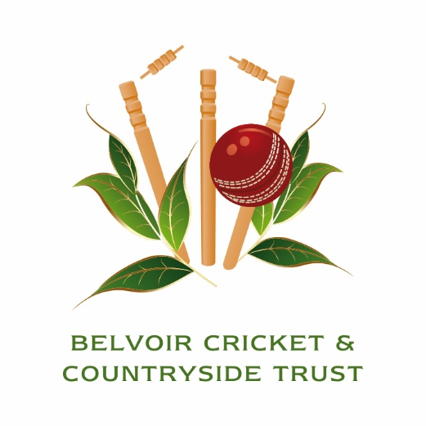
Charity 6-a-side Cricket Tournament
Friday 21st June 2024
Knipton Cricket Ground. Harston Lane, Knipton, NG32 1RE

Registration Form

Please complete the form and return with your payment to: Darren Bicknell, Belvoir Cricket and Countryside Trust, Belvoir Castle, Grantham, NG32 1PE, (Tel 07825-992406). Alternatively the form can be emailed to darren@bcctrust.org.uk and payment made by BACS (please contact us for further details).

Name: |  |  |  | Company:
Address: | Postcode:
Tel No: |  | Email:
Team Name
 |  |  | Number: |  |  |  | Cost:
Team cost £500
Extra Guests for Hospitality @ £25pp |  |  |  |  |  |  | £
TOTAL COST |  |  |  |  |  |  | £

